#09, St. 181

Sangkat Tomnub Teok,

Khan Chankamorn, Phnom Penh

12th May 2017

Mr. Chheng Limaun

Lecturer of RUPP

Room 106

Royal University of Phnom Penh

Dear Mr. Limaun

Please accept this letter and my resume attached as application for the positon of **Graphic Design**, as advertised on the whiteboard on 06th May 2017.

I am nineteen years old and in my second year at university. I am highly motivated with haft year experience as a Graphic Designer at **Digital Divide Data (DDD)**. As you will see in my CV, I have always shown my interest in working as a designer and have relevant experience from voluntary work. In this position I had sole responsibility for designing, such as logo, poster, banner, slogan and product. In addition to this, I regularly spend time in helping other to valuate and correct the lack with their photo. This hand-on experience has reinforced my decision to seek a career working as a Graphic Designer. Both the voluntary work and haft year experience would be willing to provide references.

I am hard-working, punctual and willing to help out with any kind of job at **CamIT**. My decision to undertake a degree at SETEC confirms my interest and commitment to this position. I am certain that experience working at **CamIT** will provide invaluable insight working with photo editing and a unique opportunity to acquire a range of skills and expertise.

I hope I have shown that I am an ideal candidate for this position.

I look forward to hearing from you.

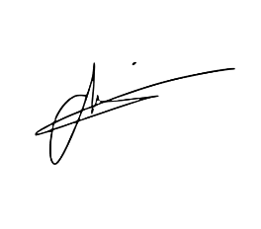Yours faithfully,

Hay Dane